Assignment 04

Cryptology – b keerthana

Amruthesh

241059041

M.E - Cyber Security

MSIS, MAHE

1. **Write a Python program to reverse the content of the string.**

**Do not use built in functions.**

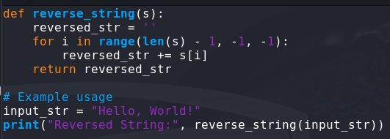

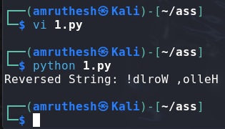

1. **Create a program that performs basic string compression using the counts of repeated characters. For example, the string “aabcccccaaa” would become “a2b1c5a3”.**

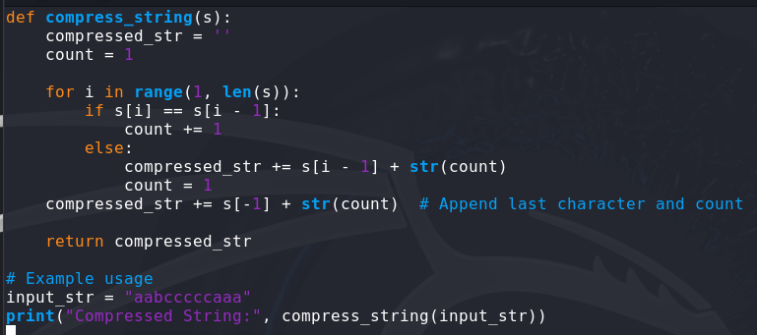

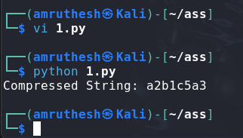

1. **Get the Caesar cipher from the user Decrypt the cipher**

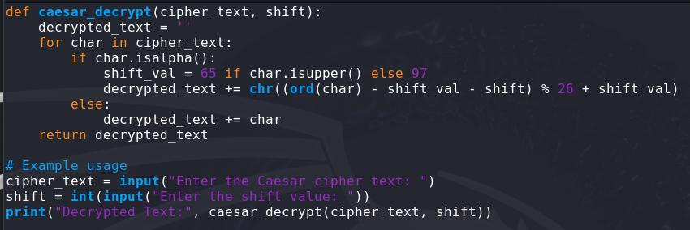

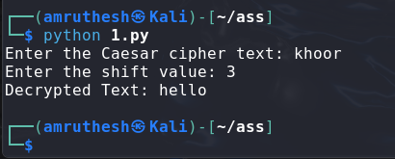

1. **Get the cipher encrypted using shift cipher. Identify the key used to encrypt using brute force. i.e, all the values in the key space**

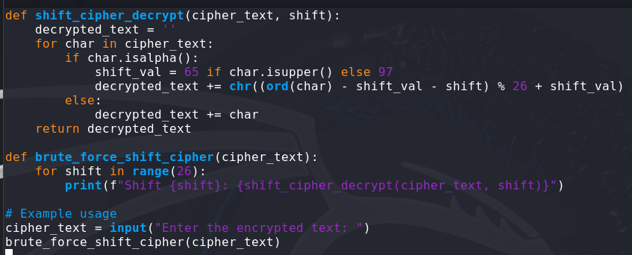

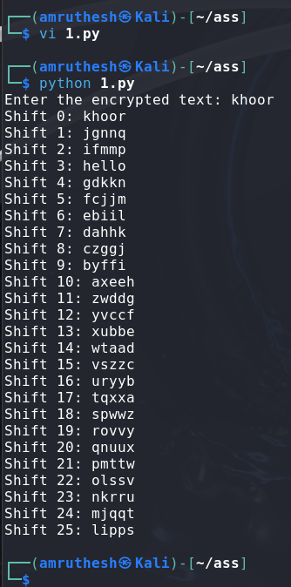

1. **Find the k value, Provided cipher text and plain text**

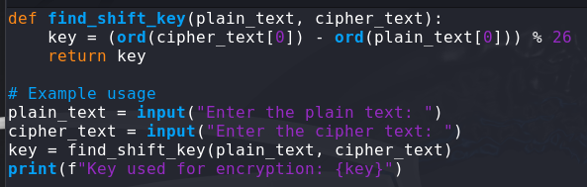

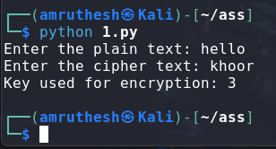

1. **Encrypt and decrypt the string using Atbash cipher**

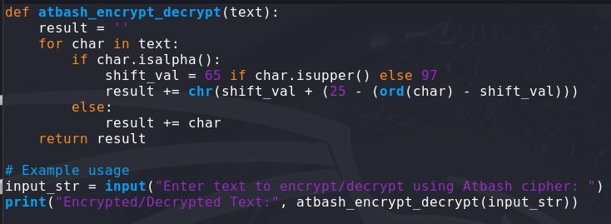

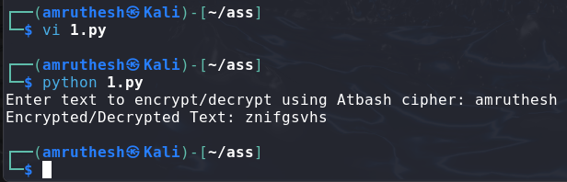

1. **Encrypt and decrypt using Affine cipher add validation**

